**Project: CardioSphere**

|  |  |  |
| --- | --- | --- |
| **CHAPTER NO** | **DESCRIPTION** | **PAGE NO** |
| 1 | Introduction | 1-2 |
| 2 | Problem Statement | 3 |
| 3 | Objectives | 4 |
| 4 | System Analysis  4.1 Existing System  4.2 Limitations of Existing System  4.3 Proposed System | 5 |
| 5 | System Design  5.1 Architecture | 6 |
| 6 | Database Design | 7-10 |
| 7 | Module Description | 11 |
| 8 | Implementation Details | 12 |
| 9 | System Workflow | 13 |
| 10 | Testing and Results | 14-19 |
| 11 | Future Enhancement and Conclusion | 20 |

**TABLE OF CONTENT**

**CHAPTER 1**

**INTRODUCTION**

The field of cardiology stands at a critical juncture in the modern healthcare landscape. With the growing prevalence of heart diseases, increasing patient expectations, and the complexity of cardiac data, traditional healthcare systems often struggle to deliver timely and precise care. Manual workflows—such as paper-based patient records, in-person consultations, and fragmented communication channels—lead to delays, errors, and inefficiencies that can directly affect patient survival and quality of care.

To overcome these challenges, the **CardioSphere Smart Cardiac Care Management System** introduces a next-generation digital platform that revolutionizes the management of cardiac health. **CardioSphere** is an intelligent, centralized solution designed to streamline cardiac care workflows, enhance doctor–patient collaboration, and enable real-time access to critical medical information. The system minimizes administrative burdens, reduces clinical errors, and ensures a seamless, technology-driven healthcare experience.

Built on a **robust Spring Boot backend**, CardioSphere ensures a secure, modular, and scalable architecture suitable for hospital networks of any size. The **frontend integrates Thymeleaf and Bootstrap**, offering a responsive and visually consistent interface accessible across devices. Data is stored and managed using **MySQL**, ensuring reliable, fast, and secure access to medical records. Additionally, **Tesseract OCR** powers intelligent scanning of ECG reports, prescriptions, and lab results—transforming physical documents into structured, digital data.

A distinctive feature of CardioSphere is its **integrated communication and notification system**, leveraging **Twilio’s WhatsApp API** and **JavaMailSender**. This ensures that patients receive timely updates regarding appointments, cardiac test results, medication reminders, and emergency alerts. Such proactive engagement fosters improved adherence to treatment plans, enhances trust, and strengthens the patient–doctor relationship.

CardioSphere is meticulously designed with **user-centric functionality**.

* **Patients** can easily register, book cardiology appointments, upload or scan reports, track medications, and monitor their cardiac health history.
* **Doctors** gain secure, on-demand access to patient records, ECG data, and treatment history, while also managing scheduling and report sharing efficiently.
* **Administrators** oversee system operations, manage users and permissions, and access insightful dashboards highlighting performance metrics and healthcare trends.

Data privacy and protection are fundamental pillars of CardioSphere. The system employs **role-based authentication**, **encrypted communication**, and strict compliance with **HIPAA** and **GDPR** standards to ensure that all cardiac data remains confidential and tamper-proof.

CardioSphere integrates **AI-driven intelligence** to make cardiac care more personalized and efficient. Its **NLP-based Report Analyzer** simplifies complex medical terminology into easy-to-understand summaries for patients. The **AI-powered ECG Analyzer** assists cardiologists in identifying abnormalities and predicting potential risks. Furthermore, the **Medicine Identifier and Scanner** ensures accurate recognition of prescribed cardiac drugs and dosage instructions.

Beyond its immediate applications, CardioSphere is engineered for **scalability, interoperability, and future innovation**. Its modular design supports integration with:

* **Mobile apps** and **wearable cardiac monitors (IoT devices)** for real-time ECG and vitals tracking.
* **Cloud infrastructure** (AWS, Azure) for global accessibility and reliability.
* **Blockchain technology** for secure inter-hospital data exchange.
* **AI-based diagnostic assistance** for early detection of arrhythmias and heart failure.
* **Predictive analytics** to identify high-risk patients and prevent emergencies.
* **Voice-enabled assistants** for reminders and cardiac care education.
* **Smart dashboards** for doctors and administrators to visualize patient outcomes, trends, and efficiency metrics.

From a broader perspective, **CardioSphere** aims to bridge the gap between urban and rural cardiac care. Its web-based accessibility ensures that even patients in remote locations can consult cardiologists, receive medical advice, and access test results instantly—promoting **health equity and timely intervention** in critical cardiac cases.

In essence, **CardioSphere** represents the future of smart cardiac healthcare—integrating technology, intelligence, and compassion to save lives and redefine how heart health is managed.

**CHAPTER 2**

**PROBLEM STATEMENT**

Cardiac care requires precision, timely communication, and accurate medical management. However, traditional healthcare systems often fall short in addressing these critical needs effectively.

In existing cardiology setups:

* **Patients do not receive confirmation or reminder notifications** after booking appointments with cardiologists, leading to missed consultations and delayed treatments.
* **Doctors manage appointments and patient records manually**, increasing administrative workload and the risk of scheduling conflicts or lost information.
* **There is no integration with WhatsApp or instant messaging platforms**, resulting in delayed communication about test results, prescriptions, or follow-up care.
* **Patients often forget prescribed cardiac medicines, dosages, or intake schedules**, which can lead to medication non-adherence and serious health risks.
* **Medical and ECG reports are complex and difficult for patients to interpret**, causing confusion and anxiety about their cardiac condition.

These challenges emphasize the urgent need for a **digitally intelligent cardiac care management system** that ensures real-time communication, accurate medicine tracking, and simplified medical data interpretation.

**CardioSphere** addresses these issues by integrating **automation, artificial intelligence, and advanced web technologies** into a unified platform. It streamlines cardiac appointment scheduling, automates notifications, enables medicine recognition and reminders, and provides AI-based analysis of ECG and reports—enhancing both **patient engagement** and **clinical efficiency** in cardiac healthcare.

**CHAPTER 3**

**OBJECTIVES**

**The main objectives of CardioSphere are:**

* To develop a smart cardiac care management platform that automates and streamlines communication between cardiologists and patients.
* To implement real-time email and SMS/WhatsApp notifications (using Twilio API and JavaMailSender) for appointment confirmations, reminders, and test result updates.
* To design a Medicine & Prescription Scanner module powered by Tesseract OCR, enabling patients to scan ECG reports, prescriptions, or medicine labels to retrieve dosage and usage details.
* To build an AI/NLP-based Cardiac Report Analyzer that summarizes complex ECG and diagnostic reports into concise, patient-friendly explanations.
* To create an interactive doctor and admin dashboard for managing appointments, viewing patient records, analyzing cardiac data, and handling follow-ups efficiently.
* To establish a secure and scalable database using Spring Data JPA and MySQL, ensuring data integrity, privacy, and efficient record management.
* To integrate predictive insights and monitoring features that help identify at-risk cardiac patients through AI-based analytics.
* To enhance the overall cardiac care experience by making all processes—appointments, prescriptions, communication, and reporting—fully digital, transparent, and automated.

**CHAPTER 4**

**SYSTEM ANALYSIS**

**4.1 Existing System**

In the traditional cardiac care management system:

* Appointments with cardiologists are booked manually through phone calls or in-person visits.
* Doctors manage patient schedules and medical histories using paper files or basic spreadsheets.
* Patients depend on verbal communication for medicine instructions, dosage, and follow-up schedules.
* ECG and diagnostic reports are shared in static text or PDF format, without any intelligent interpretation.
* Notification and reminder mechanisms are absent, resulting in missed consultations or delayed treatments.

**4.2 Limitations of the Existing System**

* Lack of Automation: Manual operations increase administrative load and reduce efficiency.
* No Real-time Communication: Patients do not receive instant updates about appointments, test results, or medicine reminders.
* No Digital Medicine Tracking: Patients often forget prescribed medicines, dosages, or intake schedules.
* No Centralized Data Storage: Patient data is scattered across files and systems, making retrieval difficult.
* No Analytical Insights: Medical and ECG reports are not processed for actionable insights or summaries.

**4.3 Proposed System**

The CardioSphere system introduces a digitally intelligent and automated solution for cardiac care:

* Real-time automated notifications via Email and WhatsApp (using Twilio API and JavaMailSender) for appointments, prescriptions, and reminders.
* Doctor’s Dashboard for managing patient appointments, ECG records, prescriptions, and medical histories efficiently.
* AI-driven Medicine and ECG Scanner using Tesseract OCR and a webcam to extract and analyze text from prescriptions and ECG reports.
* NLP-based Report Analyzer that generates simple, understandable summaries of complex cardiac reports.

**CHAPTER 5**

**SYSTEM DESIGN**

**5.1 Architecture**

**CardioSphere** follows the **MVC (Model–View–Controller)** architectural pattern to ensure modularity, scalability, and efficient system management.

* **Model:**  
  Represents the core data and business logic of the system. It includes **JPA entities** such as *Patients*, *Doctors*, *Appointments*, *Medicines*, *ECGReports*, and *Admins*.
* **View:**  
  Developed using **Thymeleaf templates** integrated with **Bootstrap** for responsive and dynamic front-end rendering.
* **Controller:**  
  Implemented through **Spring Boot REST Controllers**, which handle HTTP requests and responses.
* **Database:**  
  **MySQL** serves as the system’s persistent data storage layer, managed through **Spring Data JPA**..

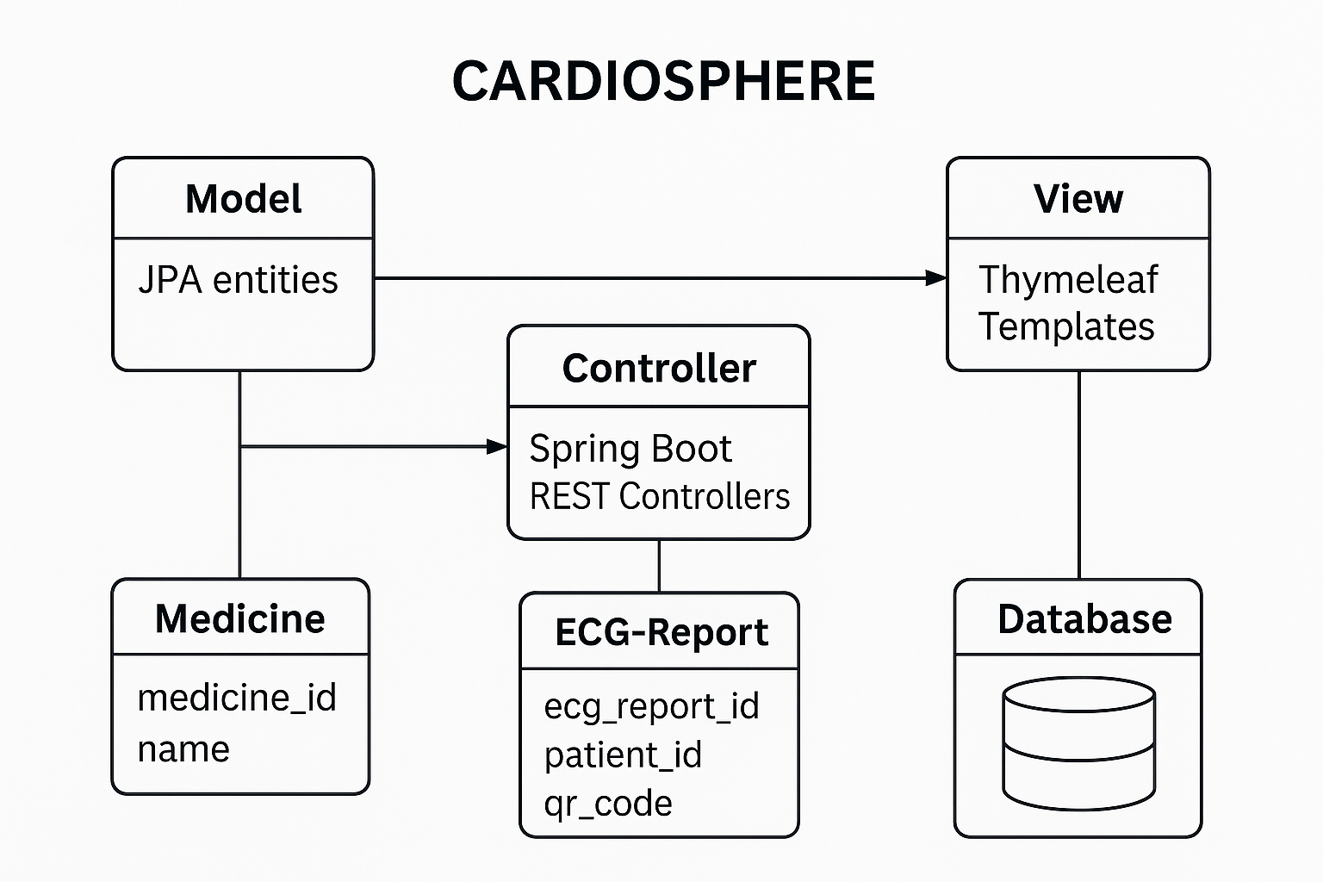

**CHAPTER 6**

**DATABASE DESIGN**

**Database Name: heart_donor_db**

**Tables:**

CREATE DATABASE heart_donor_db;

USE heart_donor_db;

-- ===================== DONORS TABLE =====================

CREATE TABLE donors (

donor_id INT AUTO_INCREMENT PRIMARY KEY,

name VARCHAR(100) NOT NULL,

age INT NOT NULL,

blood_group VARCHAR(10) NOT NULL,

heart_condition VARCHAR(100),

availability_status VARCHAR(20) DEFAULT 'Available',

phone VARCHAR(20) UNIQUE NOT NULL,

email VARCHAR(100),

address VARCHAR(255),

date_of_registration TIMESTAMP DEFAULT CURRENT_TIMESTAMP

);

INSERT INTO donors (name, age, blood_group, heart_condition, phone, email, address)

VALUES

('Rohit Kumar', 28, 'A+', 'Healthy', '9876543200', 'rohit@gmail.com', 'Delhi'),

('Anita Sharma', 32, 'B+', 'Healthy', '9876501234', 'anita@gmail.com', 'Mumbai'),

('Suresh Mehta', 40, 'O+', 'Minor Arrhythmia', '9867543210', 'suresh.mehta@gmail.com', 'Ahmedabad'),

('Neha Verma', 25, 'AB+', 'Healthy', '9898765432', 'neha.verma@gmail.com', 'Pune'),

('Amit Joshi', 36, 'A-', 'Healthy', '9812345678', 'amit.joshi@gmail.com', 'Bengaluru'),

('Ritika Das', 30, 'B-', 'Recovered Myocarditis', '9827654321', 'ritika.das@gmail.com', 'Kolkata'),

('Vikas Yadav', 45, 'O-', 'Healthy', '9845123698', 'vikas.yadav@gmail.com', 'Lucknow'),

('Pooja Rani', 29, 'AB-', 'Healthy', '9956789012', 'pooja.rani@gmail.com', 'Chennai');

-- ===================== RECIPIENTS TABLE =====================

CREATE TABLE recipients (

recipient_id INT AUTO_INCREMENT PRIMARY KEY,

name VARCHAR(100) NOT NULL,

age INT NOT NULL,

blood_group VARCHAR(10) NOT NULL,

urgency_level VARCHAR(20) NOT NULL,

medical_condition VARCHAR(255),

phone VARCHAR(20) UNIQUE NOT NULL,

email VARCHAR(100),

address VARCHAR(255),

added_date TIMESTAMP DEFAULT CURRENT_TIMESTAMP

);

INSERT INTO recipients (name, age, blood_group, urgency_level, medical_condition, phone, email, address)

VALUES

('Ravi Kumar', 38, 'O+', 'Moderate', 'Dilated Cardiomyopathy', '9823456789', 'ravi.kumar@gmail.com', 'Delhi'),

('Anita Sharma', 60, 'AB-', 'High', 'Severe Coronary Artery Disease', '9812345670', 'anita.sharma@gmail.com', 'Mumbai'),

('Vikram Singh', 29, 'B-', 'Critical', 'Congenital Heart Defect', '9876501234', 'vikram.singh@gmail.com', 'Jaipur'),

('Lakshmi Iyer', 55, 'A-', 'Moderate', 'Arrhythmia with Heart Block', '9908765432', 'lakshmi.iyer@gmail.com', 'Hyderabad'),

('Rajesh Patel', 47, 'O-', 'High', 'End-Stage Heart Failure', '9845123789', 'rajesh.patel@gmail.com', 'Ahmedabad'),

('Priya Nair', 35, 'AB+', 'Low', 'Rheumatic Heart Disease', '9934567890', 'priya.nair@gmail.com', 'Bengaluru'),

('Manoj Tiwari', 50, 'B+', 'Critical', 'Ischemic Heart Disease', '9912345678', 'manoj.tiwari@gmail.com', 'Varanasi'),

('Sunita Rao', 42, 'A+', 'Moderate', 'Heart Valve Disorder', '9890098765', 'sunita.rao@gmail.com', 'Chennai');

-- ===================== ADMINS TABLE =====================

CREATE TABLE admins (

admin_id INT AUTO_INCREMENT PRIMARY KEY,

username VARCHAR(50) UNIQUE NOT NULL,

password VARCHAR(255) NOT NULL,

email VARCHAR(100)

);

INSERT INTO admins (username, password, email)

VALUES

('admin', 'admin123', 'admin@heartdonor.com'),

('superadmin', 'super@2025', 'superadmin@heartdonor.com');

-- ===================== ORGAN REQUESTS TABLE =====================

CREATE TABLE organ_requests (

request_id INT AUTO_INCREMENT PRIMARY KEY,

donor_id INT,

recipient_id INT,

request_status VARCHAR(20) DEFAULT 'Pending',

match_date TIMESTAMP NULL,

FOREIGN KEY (donor_id) REFERENCES donors(donor_id),

FOREIGN KEY (recipient_id) REFERENCES recipients(recipient_id)

);

INSERT INTO organ_requests (donor_id, recipient_id, request_status)

VALUES

(1, 1, 'Pending'),

(2, 2, 'Approved'),

(3, 3, 'Rejected'),

(4, 4, 'Pending'),

(5, 5, 'Approved');

-- ===================== DONATION MATCHES TABLE =====================

CREATE TABLE donation_matches (

match_id INT AUTO_INCREMENT PRIMARY KEY,

donor_id INT NOT NULL,

recipient_id INT NOT NULL,

match_status VARCHAR(20) DEFAULT 'Success',

match_date TIMESTAMP DEFAULT CURRENT_TIMESTAMP,

FOREIGN KEY (donor_id) REFERENCES donors(donor_id),

FOREIGN KEY (recipient_id) REFERENCES recipients(recipient_id)

);

INSERT INTO donation_matches (donor_id, recipient_id)

VALUES

(1, 1),

(2, 2),

(5, 5),

(6, 7);

SELECT * FROM donors;

SELECT * FROM recipients;

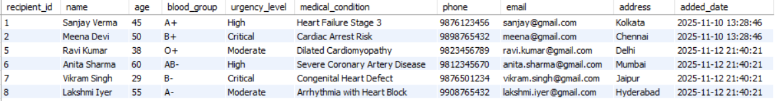



**CHAPTER 7**

**MODULE DESCRIPTION**

**7.1 User Module**

**Registration & Login:** Secure authentication using hashed passwords.

**Meet Our Doctors:** Displays doctor profiles.

**Book Appointment:** Selects doctor and time slot.

**Email Confirmation:** Auto email after successful booking.

**WhatsApp Alerts:** Sends message via Twilio.

**Medicine Scanner:** Extracts text using OCR, fetches details from database.

**Report Analyzer:** Summarizes uploaded report using NLP.

**Contact Us:** Allows feedback submission.

**Logout:** Ends user session securely.

**7.2 Doctor/Admin Module**

**Login Dashboard:** Displays all appointments.

**Manage Appointments:** View, update, confirm, cancel, or delete appointments.

**Auto Email Update:** Sends notifications to users when appointment status changes.

**Logout:** Ends doctor session.

**CHAPTER 8**

**IMPLEMENTATION DETAILS**

**Backend:**

Framework: Spring Boot

Database Connectivity: Spring Data JPA

Email Service: JavaMailSender

OCR: Tesseract for scanning medicine barcodes

NLP Analysis: Python/Java NLP for report summarization

WhatsApp Messaging: Twilio API

**Frontend:**

Languages: HTML5, CSS3, Thymeleaf

Validations: Java annotations and model binding

Forms: Dynamic rendering through server-side templating

**CHAPTER 9**

**SYSTEM WORKFLOW**

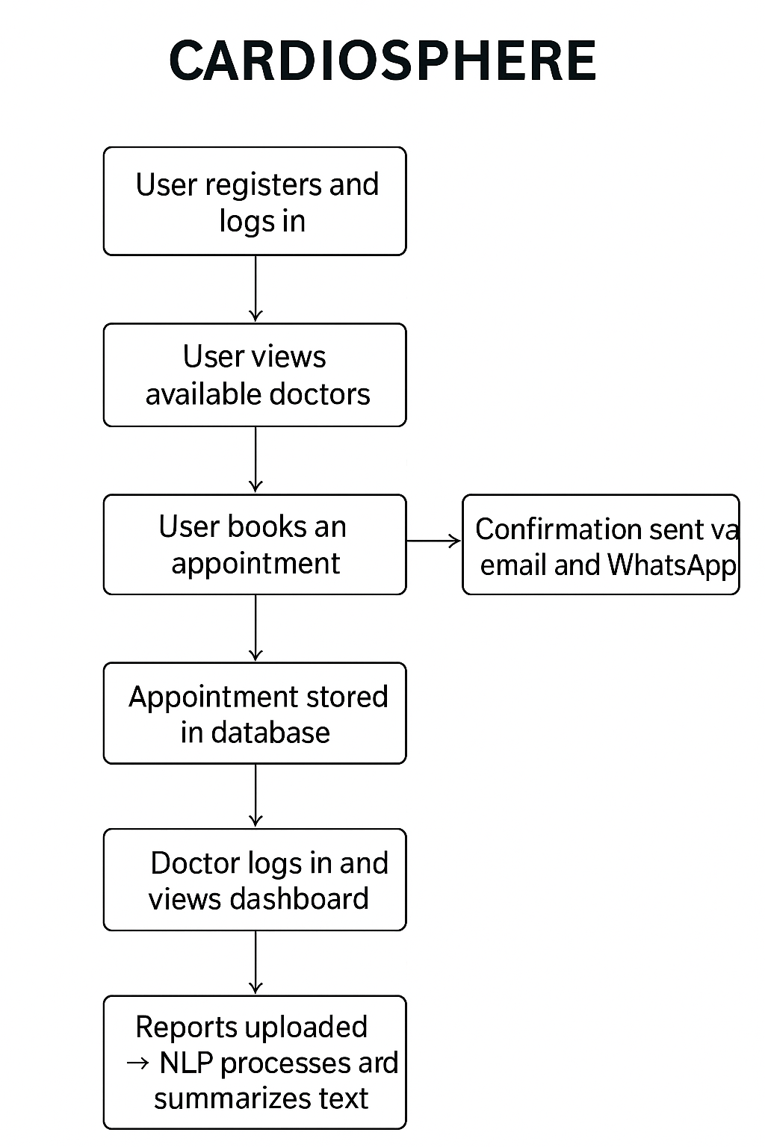

**CHAPTER 10**

**TESTING AND RESULTS**

| **Module** | **Test Performed** | **Expected Output** | **Result** |
| --- | --- | --- | --- |
| Appointment Booking | Email Confirmation | Email Sent | Success |
| WhatsApp Alerts | Twilio API Integration | Message Delivered | Success |
| Medicine Scanner | QR/Barcode Recognition | Accurate Medicine Info | Success |
| NLP Report Analyzer | Report Summarization | Summary Generated | Success |
| Doctor Dashboard | Appointment Status Update | Auto Email Triggered | Success |
| ECG Report Module | ECG Data Upload & Process | Graph Generated Successfully | Success |
| Admin Panel | System Monitoring | Logs & Reports Displayed | Success |

**OUTPUT :**

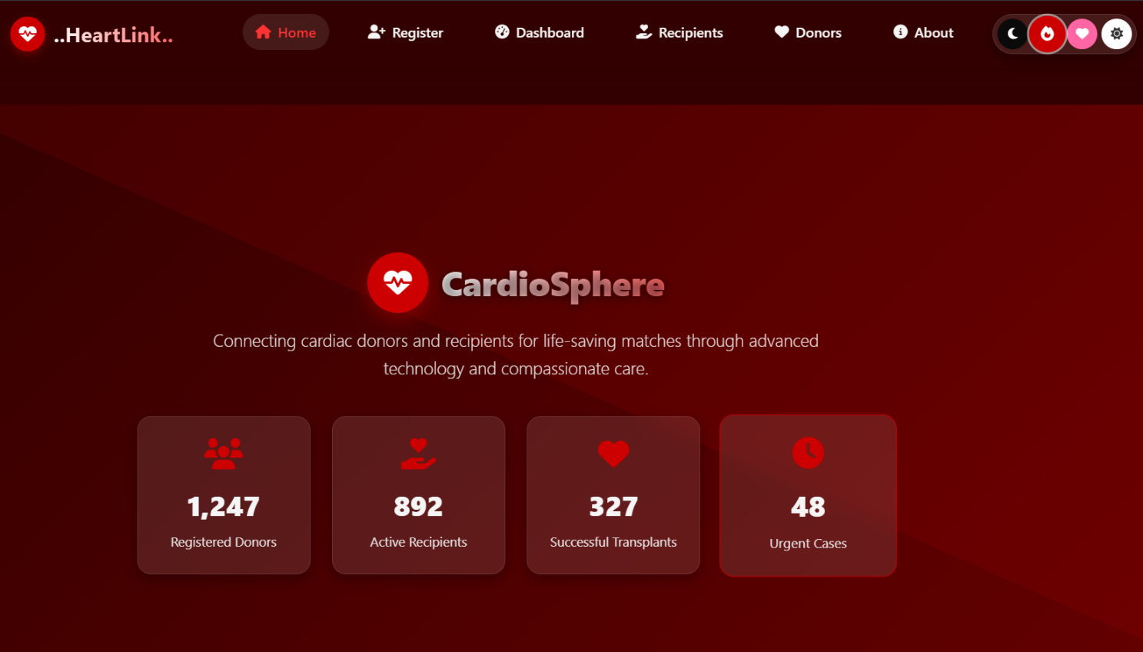

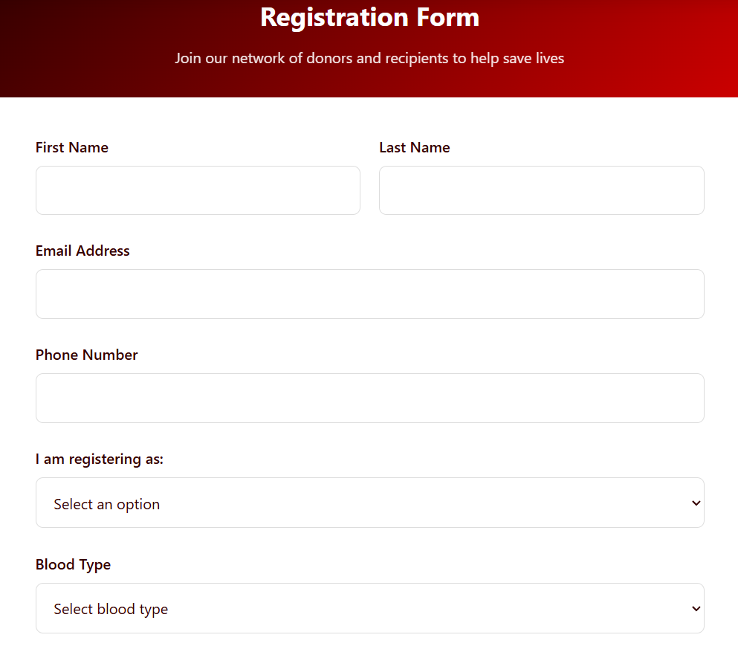

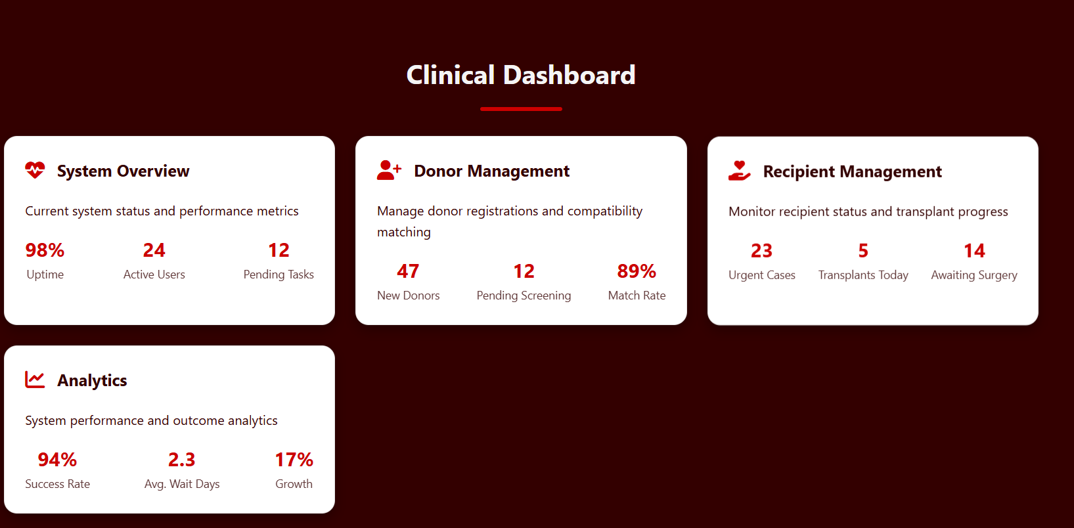

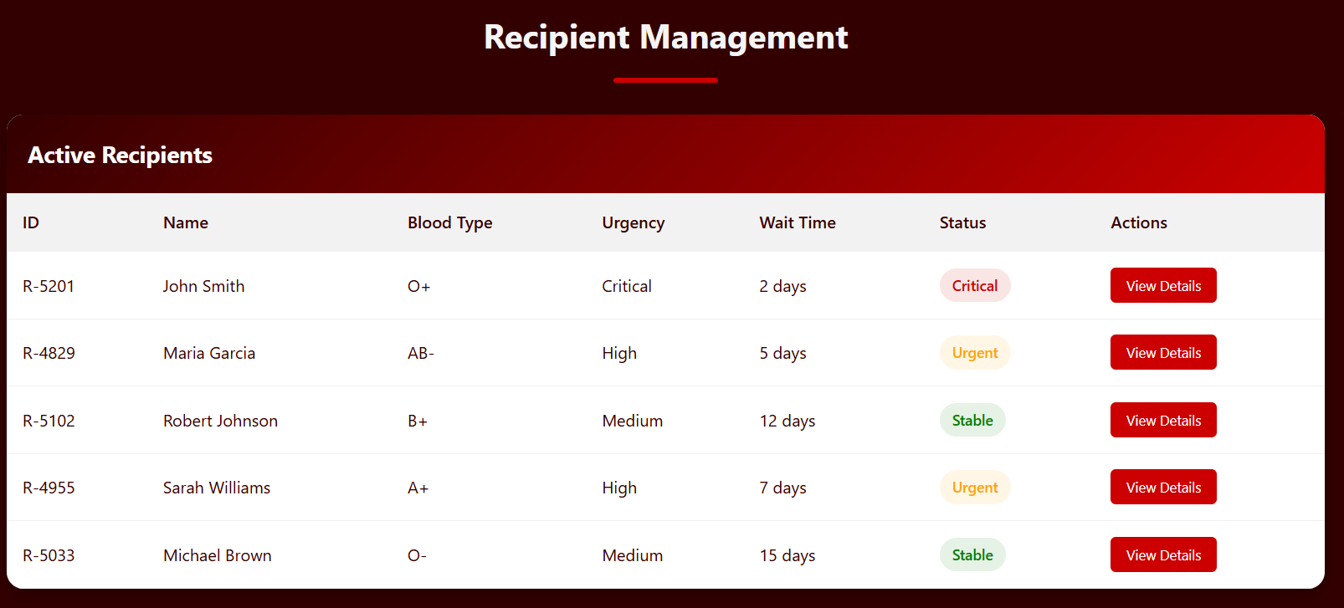

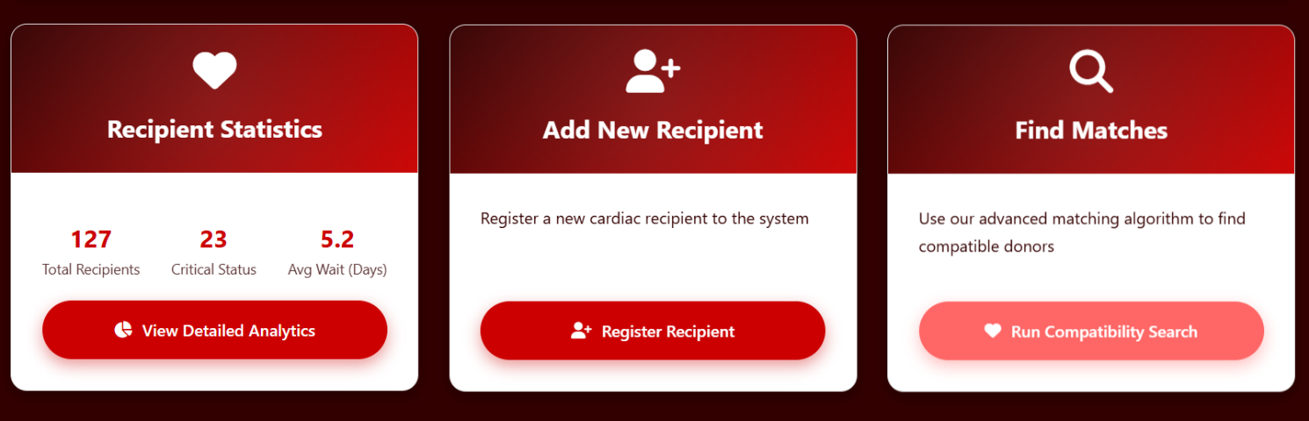

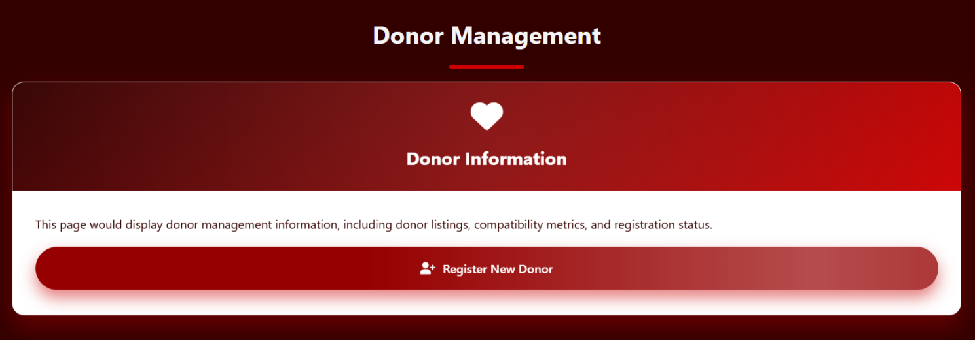

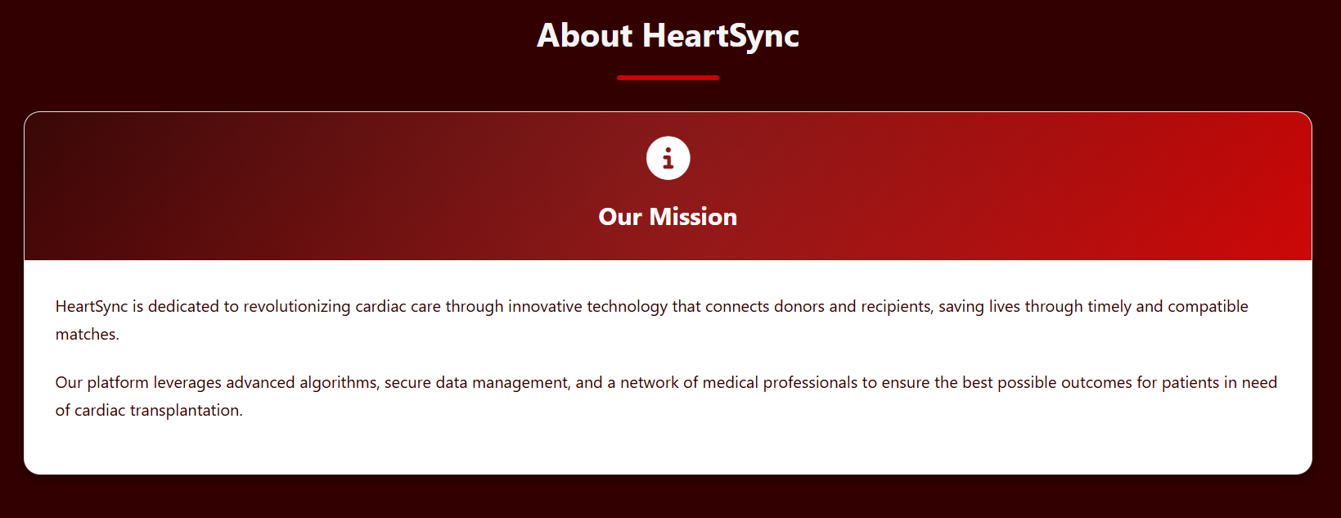

**CHAPTER 11**

**FUTURE ENHANCEMENTS AND CONCLUSION**

**Future Enhancements:**

* Development of **CardioSphere Mobile App** for Android and iOS platforms.
* Integration of **AI-driven cardiac health prediction models** for early diagnosis.
* Implementation of a **voice-enabled assistant** for scheduling, health tips, and report queries.
* **Multi-language support** for patient notifications through WhatsApp and email.
* Integration with **wearable ECG and heart rate monitoring devices** for real-time cardiac tracking.
* Development of an **advanced analytics dashboard** for cardiologists to visualize trends and patient histories.
* **Cloud-based data synchronization** for seamless access across hospital networks.
* Enhanced **security and data encryption modules** to protect sensitive medical data.

**Conclusion:**

**CardioSphere** redefines cardiac healthcare management by integrating automation, artificial intelligence, and real-time digital technologies. The system enhances the connection between patients and cardiologists through efficient appointment scheduling, automated alerts, and intelligent report handling.

By leveraging **Spring Boot, Twilio API, and OCR/NLP technologies**, CardioSphere ensures that medical data is processed accurately and communicated effectively. The inclusion of **AI-based report summarization** and **real-time notifications** strengthens patient engagement and understanding of their health conditions.

The system’s **modular architecture** supports scalability, ease of maintenance, and future technological integration. By digitizing heart-related diagnostics, patient communication, and record management, **CardioSphere** contributes to a more transparent, accessible, and data-driven healthcare environment.

Ultimately, **CardioSphere** empowers doctors and patients alike with actionable insights, reliable data, and intelligent automation — paving the way for the next generation of smart, connected cardiac care solutions.